**UE20CS352 - OOADJ**

**Lab Assignment - 1**

**Use Case Diagram and Use Case Specification**

**Name:** Vishwa Mehul Mehta

**SRN:** PES2UG20CS389

**Section:** F

**Date:** 19-01-2023

**UID Number Automation System:**

**Use Case Diagram:**

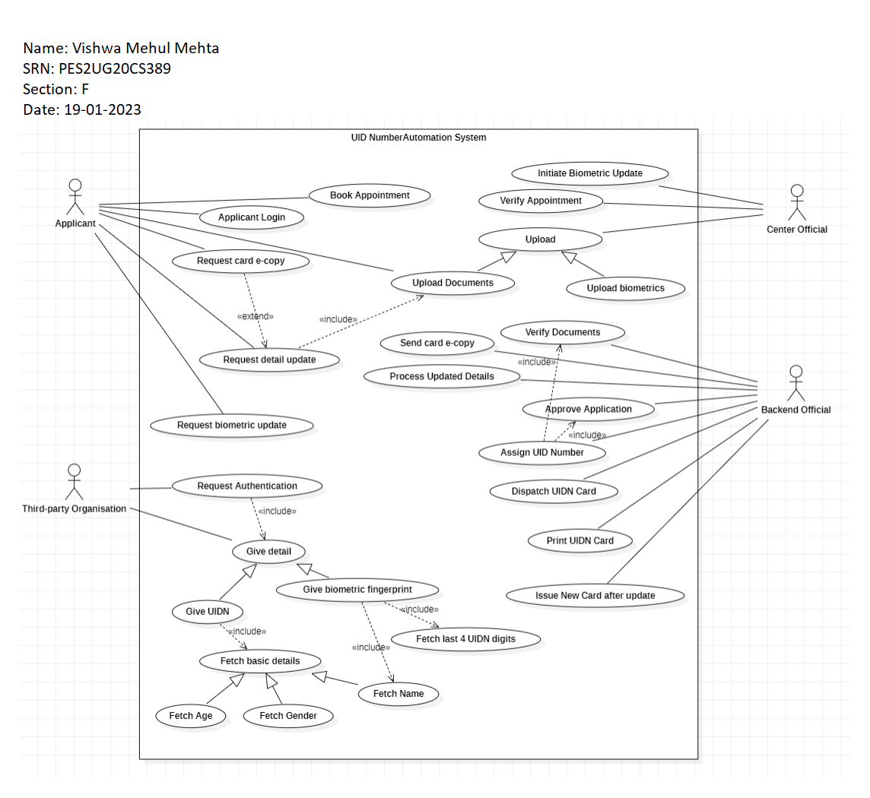

**Use Case 1:**

**Name**: Request Biometric Update

**Summary**: Update biometric details on user request

**Actors**: Applicant, Center Official

**Pre-condition**: Existing UIDN Card

**Description**: The user requests biometric update and must book an appointment at the local center which initiates the update.

**Exception**: Failed biometric update then Re-apply for update.

**Post-condition**: The update is initiated by the center official.

**Use Case 2:**

**Name**: Request Authentication

**Summary**: Third-party requests authentication can be done in 2 ways

**Actors**: Third-party organisation

**Pre-condition**: Existing UIDN

**Description**: This can be done in 2 ways - by giving UIDN or biometric fingerprint.

**Exception**: Non-existent UIDN then create new UIDN, Incorrect UIDN then re-enter UIDN

**Alternate Flow**: In case of Non-existent UIDN user must book login and book an appointment for creating it.

**Post-condition**: Giving the UIDN fetches Age, Gender and Name and the biometric fingerprint fetches the last 4 UIDN digits and the Name.